Healthwatch Rutland Board Meeting Minutes 17th June 2015 PAPER B

Minutes of Healthwatch Rutland Board held in the Audit Hall, Empingham at 7.30 pm on Wednesday 17th June 2015

Present:

Healthwatch Rutland Board

Jennifer Fenelon, Chair
Christine Stanesby

Bart Hellyer

Judy Worthington

In attendance

Ali Burrow-Smith, Chief Executive , Healthwatch Rutland

Healthwatch Volunteers, Members of the public and Healthwatch Members

Daphne Murphy , Christine Sparks, Jacqui Darlington, Ketan Paw and five members of the public

15.39 Welcome and apologies for absence
The Chair welcomed members of the public to this first " Board on the Road" meeting held by the Board of Healthwatch Rutland. Apologies for absence were received from David Henson who was delayed at a previous meeting.

15.40 Purpose of the Meeting
The Chair explained that formal Board Meetings are normally held at Voluntary Action Rutland but Board Members were anxious to meet members of the public in a more informal setting so that they could hear first hand people's experiences of Health and Social Care.

She asked if members of the public would give their feedback at the end of the meeting as to how effective it had been so that future meetings could be well planned. It was planned to give a brief outline of Healthwatch Rutland - its purpose and what it is doing for Rutland people followed by free ranging discussion of issues.

15.41 Healthwatch Rutland
A small booklet had been prepared in advance to outline the work of Healthwatch Rutland and is appended to the minutes for information . It was used as an agenda for the meeting.

Board Members and volunteers described individual projects being undertaken and the work they were doing

15.42 Health and Social Care Issues.

Members of the public engaged with Board Members and Volunteers on a very wide range of subjects and a very lively debate followed for nearly two hours .Several of the issues raised related to the workings of other organisations such as the CCG,GEM and Rutland County Council and it was noted that guest speakers were invited from commissioner and provider organisations to discuss hot topics and proposed changes. Other issues raised would be taken to the organisations concerned where Healthwatch had a participating non voting role.

Members of the public were given copies of various Healthwatch publications and asked if they would test out the suitability of the new Healthwatch Health and Social Care Directory.

At the end of discussion members of the public said they had found the event very useful and had been pleasantly surprised that they were able to participate so fully in discussion in a very informal way . They felt that the events could be publicised more widely to ensure a wider audience for future events.

They welcomed the initiative and felt it should be extended as widely as possible to reach as many communities as possible.

There was further discussion as to where future meetings should be held after the New Year and Judy Worthington asked that villages on the fringes which used services in Rutland should not be forgotten.

In response members of the Board said they had found it extremely useful to hear people's issues so directly and thanked those who had both attended and acted as guinea pigs for this first event of its kind.

15.38 Dates of future meetings

- Friday 17th July 2015 1.30- 4pm, Gover Centre ,Voluntary Action Rutland ( Formal)
- Wednesday 19th August 2015 - 6.30 - 8.30pm -Village Hall ,Lyddington ( "Board on the Road")
- Friday 18th September 2015 - 1.30-4pm - AGM Uppingham Surgery ( Formal)
- Thursday 15th October - 7.30- 9.30 on Village Hall, Ryhall ( "Board on the Road")
- Friday 20th November 2015 - 1.30- 4pm, Gover Centre ,Voluntary Action ( Formal)
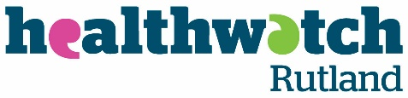
2015/16

Here for Rutland People of all ages

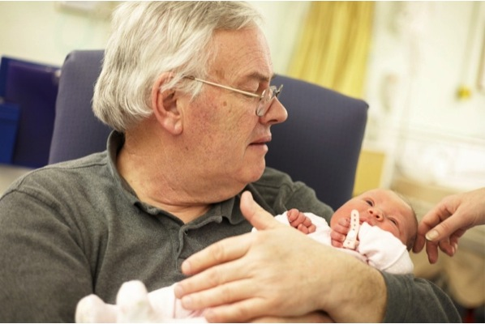

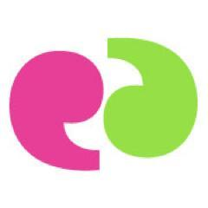
Board on the Road

Healthwatch Rutland is operated by Healthwatch Rutland Community Interest Company, a not for profit organisation established to serve the community of Rutland (no.08943486)

Welcome to Healthwatch Rutland
Board on the Road

Healthwatch Rutland (HWR) has three main functions:
- to listen to the views and concerns of people in Rutland who use health and social care services;
- to influence and challenge the way that health and social care services are provided locally;
- and to enable Rutland people to find out about the services available to meet their needs
​​We give people a powerful voice locally and nationally. At a local level, local Healthwatch works to help local people get the best out of their local health and social care services. Whether it's improving them today or helping to shape them for tomorrow.

What we do
We believe that people who use health and social care services and their experience should be at the heart of the NHS and social care services. That’s why we want to find out what you really think.
We use the information we gather to spot important local issues and trends. And we carry out our own research into those issues that need more investigating, working closely with existing voluntary and community groups and the authorities.
We have powers in law which give us influence. We will feed back what we discover to the authorities, who have a legal responsibility to use our findings to shape and improve services. This means you can be reassured that your views really do count.

How we work
We gather first-hand experience from the people of Rutland and translate it into recommendations for the local health and social care authorities. We sit on the Health and Wellbeing Board at Rutland County Council, which gives us the power to influence local decision-making about health and social care. The information we share there helps them make important decisions about your local services.

We listen

Our " We are Listening 2014" roadshows identified a range of pressing issues for Rutland people. “We are listening 2015” is about to start across the County

We follow up specific issues with more detailed surveys/ enquiries

We influence improvement

We work with a wide range of commissioners and providers.

We sit on a wide range of Boards

We meet Chief Executives

We carry out “Enter & View to see services first hand.

We signpost people

Where services are


How to complain

Where to find support

Issues we have tackled in our

first twelve months
- Young People's Mental Health Survey. 1000 young people told us that mental health is their major challenge. We will shortly publish what they have to say and we are working with 40 different organisations across Health, Education and local authority to develop a service that responds to their needs
- Dementia Mapping Project. We are working with a range of services e.g. Rutland County Council to establish the baseline for the development of Dementia services. This includes not only a map of current services but Patient/Carer opinion of services.
- Ambulance transport Transport is a huge issue for rural Rutland The HWR Chair represents Healthwatch in East Midlands on the East Midlands Ambulance Service (EMAS) Main Board and we have set up a local joint working group with EMAS to study local data and the issues people tell us about. We have held public meetings to obtain public views on the proposed development of services (especially for rural areas).
- Younger Disabled Unit We were appalled by the unit at Leicester General and are pressing hard to get it demolished and rebuilt.
- Better Care Together HWR is closely involved in the development of the LLR
5 year Plan. As Chair of the LLR Patient and Public Participation Group
Jennifer Fenelon is able to influence the Rutland public's input into these plans.
We are committed to working with RCC to support the Better Care Together Fund.

- Monitoring and action on hot topics We keep major issues under surveillance at each Board Meeting eg
  - Cancer targets,
  - The Care Act
  - Facilities in Hospitals
  - Access to GPs
  - We also contribute to confidential enquiries where we have been given information by whistle blowers.
- Consultations We are contributing to the following current consultations through holding public events: - Congenital Heart Disease standards; Urgent Care; Pharmaceutical Needs and several others
- Information giving sessions We hold public information sessions on a variety of current topics. These have included: - Personal Health budgets; SEND reforms; Care Act etc.
- Collaboration We contribute to over 40 committees at local, regional and national level.

Over to you

Our main purpose today is to listen to you.

Tell us what you think about Health and Social care for Rutland People

‘Have Your Say’

There are several ways to get in touch

 | Healthwatch Rutland c/o Voluntary Action Rutland, Lands End Way, Oakham Rutland LE15 6RB
 | 01572 720381 (answerphone available)
 | info@healthwatchrutland.co.uk
 | www.healthwatchrutland.co.uk
 | www.facebook.com/healthwatchrutland
 | @HWRutland

