

Healthwatch Rutland meeting in public

Date: Friday 23rd January 2015 1.30-4.00pm
Venue Gover Room, Voluntary Action Rutland
Lands End Way, Oakham, LE156RB

A G E N D A
Item | Lead | Report
1. Welcome, introductions & apologies | Chair
2. Declarations of interest | All
3. Minutes of the last meeting  To approve the minutes of the previous Board Meetings held on Friday 21st November 2014 | Chair | Paper A
4. Progress log  Update on actions taken. | Chair | Paper B
5. Matters arising  Matters arising from the minutes not covered by the agenda | Chair
6. Presentation and public discussion of forward Plans from East Midlands Ambulance Service  - Tim Slater, General Manager for Leicester, Leicestershire & Rutland, and Mick Jones, Locality Manager, East Midlands Ambulance Service, will present the forward plans for developing the Ambulance services for Rutland  - Questions & Answers ( including public discussion of issues) |  | Paper C
7. Development and delivery of Healthwatch Rutland.  7.1 Operational Group and Task Groups  7.2 Enter & View  7.3 PLACE  7.4 Dementia Project  7.5 Young People's Team  7.6 Mental Health  7.7 Learning Disabilities  7.8 Carers  7.9 Urgent Care 1  7.10 Urgent Care 2  7.11 We are listening  7.12 Partnership working  7.13 Communications  7.14 Half Year Stocktake  7.15 Recruitment and support of volunteers  7.16 Moving forward into 2015-16 |  | Paper D
8. Policy and other matters requiring consideration by Healthwatch Rutland Board  To consider the following reports and prepare a response to current consultations:  - Healthwatch Rutland Forward Development Plan 2015-16 - For discussion & Decision  - Public Engagement Plan 2015-16 & Better Care Together Engagement Programme  - Urgent Care UHL- The Sturgess Report  - Community Services Strategy  - Access to General Practice  - Changing the NHS Commissioning system  - Healthwatch England - Mental Health Briefing | Chair | Paper E
8. Questions from members of the public  To receive questions from members of the public | Public
9. Any other urgent Business
10. Dates of Future meetings
- Friday 20th March 2015 - Gover Centre ,Voluntary Action Rutland
- Friday 15th May 2015 - Gover Centre ,Voluntary Action Rutland
- Friday 18th September 2015 - Gover Centre ,Voluntary Action Rutland
- Friday 20th November 2015 - Gover Centre ,Voluntary Action Rutland

FOR THIS AGENDA IN ANOTHER FORMAT eg LARGE PRINT OR BRAILLE, PLEASE CONTACT HEALTHWATCH RUTLAND

By telephone- 01572 720381
@ By email -info@healthwatchrutland.co.uk

VOLUNTARY ACTION RUTLAND

How to get there:

By bus:

For the Oakham Hopper local bus timetable click here
Use Route Three and dismount behind the Rutland County College For bus services to/from other areas, click here

By train:

On foot: Leave the station by the exit to Platform 2, turn right along Barleythorpe Road to the first junction, bear right into Lands' End Way. The volunteer Centre is about 200 metres on the left-hand side. The entrance to the car park is just after the Volunteer Centre .

By car:


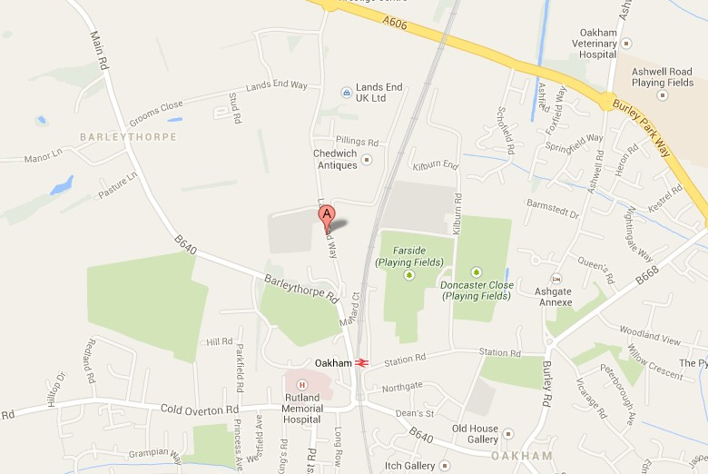
Free parking on site, including spaces for people with disabilities.

