

Healthwatch Rutland meeting in public

Date: Friday 20th November 2015 1.30-4.00pm
Venue: Gover Room, Voluntary Action Rutland
Lands End Way, Oakham, LE156RB

A G E N D A
Item | Lead | Report
1. Welcome, introductions & apologies | Chair
2. Declarations of interest | All
3. Minutes of the last meeting  To approve the minutes of the previous Board meetings held on:-  - Friday 17th July 2015  - Friday 18th September 2015 ( AGM) | Chair | Papers A & B
4. Progress log  Update on actions taken. | Chair | Paper C
5. Matters arising  Matters arising from the minutes not covered by the agenda | Chair
6. Dental Health and Care in Rutland  - Mr Jason Wong , Chair of the Leicestershire Lincolnshire Dental Local Professional Network for NHS England & Vice Chair of the Oral Health promotion partnership board LLR and practicing dentist will discuss dental health and care in Rutland . Trish Crowson of Leicestershire County Council will describe the data for Rutland and what is being done. Jane Green of NHS England will focus on the recent emergency care consultation  - Questions & Answers | Jason Wong, Trish Crowson and Jane Green | Paper D
7. Development and delivery of Healthwatch Rutland - Chair update report  To receive and discuss | Chair | Paper E
8 Healthwatch Contract - Management Accounts  To receive and note the management accounts for the first and second quarter of 2015-6 | Freida Dell | Paper F
9. Healthwatch Contract with Rutland County Council - Mid Year Report  To note the attached report which has also been sent to the Adult Scrutiny Committee of Rutland County Council | Chair | Paper G
11. Draft Strategy for Community Services in Rutland  To receive and discuss the draft strategy for Community Services currently the subject of engagement by East Leicestershire & Rutland CCG . Full consultation document available on  https://eastleicestershireandrutlandccg.nhs.uk/wp-content/uploads/2015/12/A-future-Community-Services-Model-ELR-CCG.pdf. | Chair | Paper H
12 Young People's Mental Health  To report progress and note a paper presented to the Rutland Health and Wellbeing Board on 17th November 2017 .Health and Well Being Board agenda papers available on https://rutlandcounty.moderngov.co.uk/ieListDocuments.ASPX?CID=213&MID=302 | Chair | Paper I
13 . Emergency Services including Ambulances  - Out of Hours & 111  - Ambulance transport  - A&E | Chair | Paper J
13 Better Care Together Update | Chair | Verbal
13. Policy and other matters for consideration by Healthwatch Rutland Board  - Children's Public Health  - Primary Care Enquiry  - National Financial Situation  - Junior Doctors Action  - CQC Inspections in Rutland  - Rutland County Council Local Plan  - Commissioning of Specialist services | Chair | Paper K
14. Questions from members of the public | Public
15. Any other urgent Business
16.
Dates of Future formal HWR Board meetings - 2016( All formal meetings in the Gover Centre, Voluntary Action Rutland )
- Friday 15th January 2016 1.30-4pm
- Friday 18th March 2016 - 1.30-4pm
- Friday 20th May 2016 - 1.30- 4pm
- Friday 15th July 2016 1.30- 4pm
- Friday 16th September 2015 1.30-4pm ( Provisionally earmarked as AGM)

Provisional dates of travelling HWR Board meetings to meet the people of Rutland villages (HWR Board-on-the-road) - 2016 (All evening meetings 7.30 - 9.30 . Venues to be confirmed)
- Friday 19th February- 7.30-9.30pm
- Friday 15th April 2016- 7.30-9.30pm
- Friday 17th June 2016 - 7.30-9.30pm
- Friday 19th August 2016- 7.30-9.30pm
- Wednesday 16th September 2016 - 7.30-9.30pm

FOR THIS AGENDA IN ANOTHER FORMAT eg LARGE PRINT OR BRAILLE, PLEASE CONTACT HEALTHWATCH RUTLAND By telephone- 01572 720381 By email -info@healthwatchrutland.co.uk

VOLUNTARY ACTION RUTLAND

How to get there:

By bus:

For the Oakham Hopper local bus timetable click here
Use Route Three and dismount behind the Rutland County College For bus services to/from other areas, click here

By train:

On foot: Leave the station by the exit to Platform 2, turn right along Barleythorpe Road to the first junction, bear right into Lands' End Way. The volunteer Centre is about 200 metres on the left-hand side. The entrance to the car park is just after the Volunteer Centre .

By car:


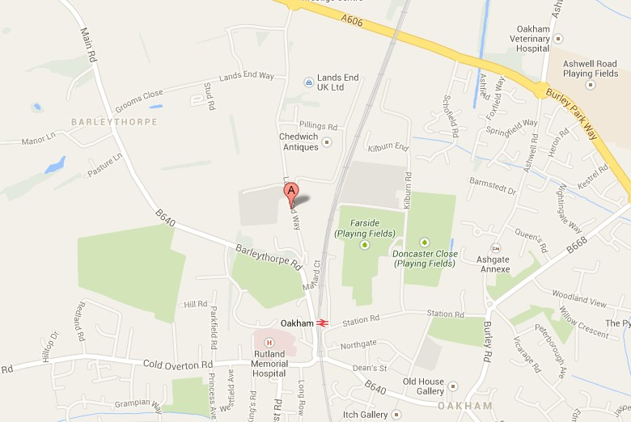
Free parking on site, including spaces for people with disabilities.

