

Healthwatch Rutland meeting in public

Date: Friday 20th May 2016 1.30-4.00pm
Venue: Gover Room, Voluntary Action Rutland
Lands End Way, Oakham, LE156RB

A G E N D A
Item | Lead | Report
1. Welcome, introductions & apologies | Chair
2. Declarations of interest | All
3. Minutes of the last meeting  To approve the minutes of the previous Board meetings held on Friday 18th March 2016 | Chair | Paper A
4. Progress log  Update on actions taken. | Chair | Paper B
5. Matters arising  Matters arising from the minutes not covered by the agenda/progress log | Chair
6 Spotlight on Young People's Mental Health  This 'Spotlight' session will include the first public showing of a documentary called " Are the kids coping?" in which the young people of Rutland describe their experiences of mental health issues . Highly recommended viewing. | Dr A Williams | Film
7 . General Manager Update  To receive a report from Sarah Iveson , General Manager | General Manager | Paper C
8. Healthwatch Contract - Management Accounts  To receive and note the management accounts for the first month of 2016-17 | Chair | Paper D
9. Annual Report and AGM  To discuss arrangements | Chair | Verbal
10 Draft Dementia Report  To receive the draft interim report of the Dementia task Group | Chair | To be circulated separately after as paper E after Task Group on 13.05.16
11. Oakham Neighbourhood Plan  To receive an update | Chair | Verbal
Item | Lead | Report
12. Ambulance Service Matters  To note Ambulance Service access times for East Midlands including Rutland for  March & April 2016 and to note the CQC report on EMAS link  http://www.cqc.org.uk/location/RX901 | Chair | Paper F
13. CQC 'Tell us about your care' partnerships  Week beginning 16th May 2016 the CQC is asking organisations to submit an expression of interest in delivering our ‘Tell us about your care’ partnerships programme for 2016/17.Further detail will be brought to the Board after the launch | Chair | Verbal
14. Policy and other matters for consideration by Healthwatch Rutland Board  - CNCS goes into Administration .  - A report of investigations into unsafe practices  - CCG Consultations  - " Catalyst or Distraction ?"  - A different ending: End of life care review  - Mental Health Act Annual Report 2014/15.  - Tackling Poor Oral Health in Children  - CQC Inspections affecting Rutland | Chair | Paper G
15. Questions from members of the public | Public
16. Any other urgent Business | Board Members
17. Dates of Future formal HWR Board meetings - 2016( All formal
meetings in the Gover Centre, Voluntary Action Rutland )

- Friday 15th July 2016 1.30- 4pm
- Friday 16th September 2015 1.30-4pm ( Provisionally earmarked as AGM)

FOR THIS AGENDA IN ANOTHER FORMAT eg LARGE PRINT OR BRAILLE, PLEASE CONTACT HEALTHWATCH RUTLAND By telephone- 01572 720381 By email -info@healthwatchrutland.co.uk

VOLUNTARY ACTION RUTLAND

How to get there:

By bus:

For the Oakham Hopper local bus timetable click here
Use Route Three and dismount behind the Rutland County College For bus services to/from other areas, click here

By train:

On foot: Leave the station by the exit to Platform 2, turn right along Barleythorpe Road to the first junction, bear right into Lands' End Way. The volunteer Centre is about 200 metres on the left-hand side. The entrance to the car park is just after the Volunteer Centre .

By car:


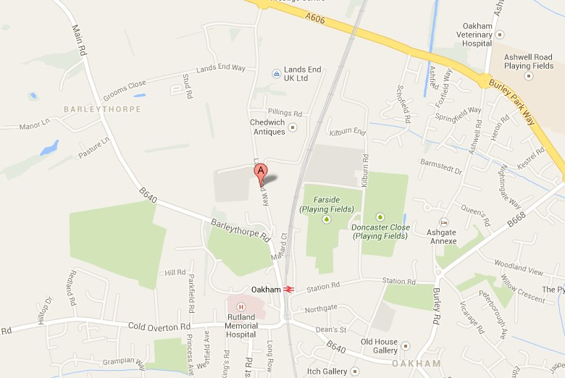
Free parking on site, including spaces for people with disabilities.

