

Healthwatch Rutland meeting in public

Date: Friday 18th March 2016 1.30-4.00pm
Venue: Gover Room, Voluntary Action Rutland
Lands End Way, Oakham, LE156RB

A G E N D A
Item | Lead | Report
1. Welcome, introductions & apologies | Chair
2. Declarations of interest | All
3. Minutes of the last meeting  To approve the minutes of the previous Board meetings held on Friday 15th January 2016 | Chair | Paper  A
4. Progress log  Update on actions taken ( Paper B) . | Chair | Paper B
5. Matters arising  Matters arising from the minutes not covered by the agenda/progress log | Chair
6 Possible Changes to Social Care Charging  To note current consultation and to receive a presentation on the proposals from Rutland County Council | RCC Representative
7 . General Manager Update  To receive a report from Sarah Iveson , General Manager | General Manager | Paper C
8. Healthwatch Contract - Management Accounts  To receive and note the management accounts for the first three quarters of 2015-6 and discussion of emergency work on the website | Chair | Paper D
9 . Emergency Services including Ambulances  To update Board Members | Chair | Verbal
10. Young People's Mental Health  To update Board Members on funding issues | Chair | Verbal
11. Dentistry issues  To update Board Members on the planned availability of NHS dentistry in  Rutland | Chair | Verbal
Item | Lead | Report
12. Healthwatch Planning for 2016-17  - Finishing off 2015-16 - Paper G describes key messages and actions taken during 2015-16 over a wide range of services and which will form the summary reports for publication/website as agreed at the Board's January meeting. There proposals have been prepared in conjunction with the Operations Group  - Proposals for 2016-17 - Paper G contains proposed actions during 2016-17. The main driver for this wide spectrum of topics is to enable Healthwatch Rutland to contribute to Better Care Consultation which will dominate our agenda during 2016-17  - Proposed Budget 2016-17- Paper G also contains a draft budget for 2016-17 . The HWR budget remains pegged at £65,000 so much of our effectiveness will depend on securing resources from the Better Care Together consultation budget. | Chair | Paper E
13. Policy and other matters for consideration by Healthwatch Rutland Board  - Oakham Neighbourhood plan  - Rutland County Council Adult Care Strategy  - NHS England - Principles and expectations for good adult rehabilitation  - Why older people are afraid to complain - " Breaking Down Barriers " - The Ombudsman  - Sue Noyes, EMAS CEO to stand down  - CQC Inspections affecting Rutland including CQC visit to UHL 20th June 2016  - NHS Citizen's Jury report | Chair | Paper F
14. Questions from members of the public | Public
15. Any other urgent Business | Board Members
16. Dates of Future formal HWR Board meetings - 2016( All formal meetings in the Gover Centre, Voluntary Action Rutland )

- Friday 20th May 2016 - 1.30- 4pm
- Friday 15th July 2016 1.30- 4pm
- Friday 16th September 2015 1.30-4pm ( Provisionally earmarked as AGM)

Travelling HWR Board meetings to meet the people of Rutland villages
- Wednesday March 16th - 7.30-9.30pm - As part of presentation evening by local organisations serving Barrowden Parish . Village Hall

FOR THIS AGENDA IN ANOTHER FORMAT eg LARGE PRINT OR BRAILLE, PLEASE CONTACT HEALTHWATCH RUTLAND By telephone- 01572 720381 By email -info@healthwatchrutland.co.uk

VOLUNTARY ACTION RUTLAND

How to get there:

By bus:

For the Oakham Hopper local bus timetable click here
Use Route Three and dismount behind the Rutland County College For bus services to/from other areas, click here

By train:

On foot: Leave the station by the exit to Platform 2, turn right along Barleythorpe Road to the first junction, bear right into Lands' End Way. The volunteer Centre is about 200 metres on the left-hand side. The entrance to the car park is just after the Volunteer Centre .

By car:


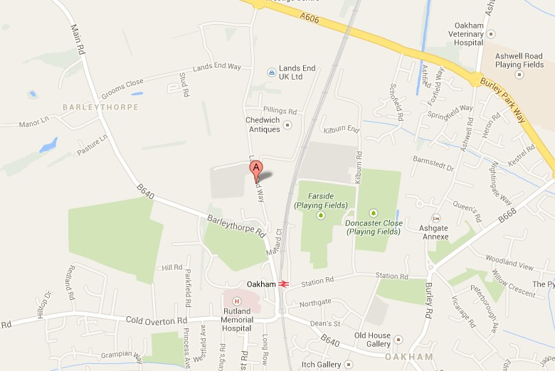
Free parking on site, including spaces for people with disabilities.

