

Healthwatch Rutland meeting in public

Date: Friday 17th July 2015 1.30-4.00pm
Venue: Gover Room, Voluntary Action Rutland
Lands End Way, Oakham, LE156RB

(Note - the meeting will be preceded by a public discussion on the future of Maternity Services 12 noon- 1.15pm)

A G E N D A
Item | Lead | Report
1. Welcome, introductions & apologies | Chair
2. Declarations of interest | All
3. Minutes of the last meeting  To approve the minutes of the previous Board meetings held on Friday 15th May 2015 and Wednesday 17th June 2015 | Chair | Papers A & B
4. Progress log  Update on actions taken. | Chair | Paper C
5. Matters arising  Matters arising from the minutes not covered by the agenda | Chair
6. Developments in Primary Care  - Tim Sacks , Chief Operating Officer of East Leicestershire and Rutland CCG will attend to discuss new developments in Primary Care including the new urgent care service, GP Federations and access to Medical records.  - Questions & Answers | Tim Sacks
7. Development and delivery of Healthwatch Rutland - Report from CEO  To receive and discuss :-  - Operational Group and Task Groups  - Enter & View  - Dementia Project  - Young People's Team  - Mental Health  - Learning Disability  - Carers  - Urgent Care 1 – Emergency Ambulances  - Urgent Care 2 – Minor Injuries & Urgent Care  - Partnership Working  - Communications  - Recruitment and Support of Volunteers | CEO | Paper D
8 Healthwatch Contract - Management Accounts  To receive and note the management accounts for the first quarter of 2015-6 | CEO | Paper E
9 CQC Inspections  To note the following CQC inspections :-  - Leicester City, Leicestershire and Rutland Out of Hours Service  - Leicestershire Partnership Trust | Chair | Paper F
10. Annual Report and AGM  To receive the annual report and to discuss outline arrangements for the AGM | Chair | Pager G
11 Young People's Mental Health  To report progress and note a paper presented to the Rutland Health and Wellbeing Board for its next meeting on 23rd July 2015 and open letter to CCGs | Chair | Paper H
12 To receive a report from David Henson from UHL Board | D Henson | Paper I
13. Policy and other matters requiring consideration by Healthwatch Rutland Board  - Specialised Commissioning  - Prescription Service Survey  - Accessible Information Standard  - Lampard Report  - Safeguarding Board | Chair | Paper J
14. Questions from members of the public | Public
15. Any other urgent Business
16. Dates of Future meetings
- Wednesday 19th August 2015 - 6.30 - 8.30pm -Village Hall ,Lyddington
- Friday 18th September 2015 - 1.30-4pm - AGM Uppingham Surgery
- Thursday 15th October - 7.30- 9.30 on Village Hall, Ryhall
- Friday 20th November 2015 - 1.30- 4pm on Gover Centre ,Voluntary Action Rutland

FOR THIS AGENDA IN ANOTHER FORMAT eg LARGE PRINT OR BRAILLE, PLEASE CONTACT HEALTHWATCH RUTLAND

By telephone- 01572 720381
@ By email -info@healthwatchrutland.co.uk

VOLUNTARY ACTION RUTLAND

How to get there:

By bus:

For the Oakham Hopper local bus timetable click here
Use Route Three and dismount behind the Rutland County College For bus services to/from other areas, click here

By train:

On foot: Leave the station by the exit to Platform 2, turn right along Barleythorpe Road to the first junction, bear right into Lands' End Way. The volunteer Centre is about 200 metres on the left-hand side. The entrance to the car park is just after the Volunteer Centre .

By car:


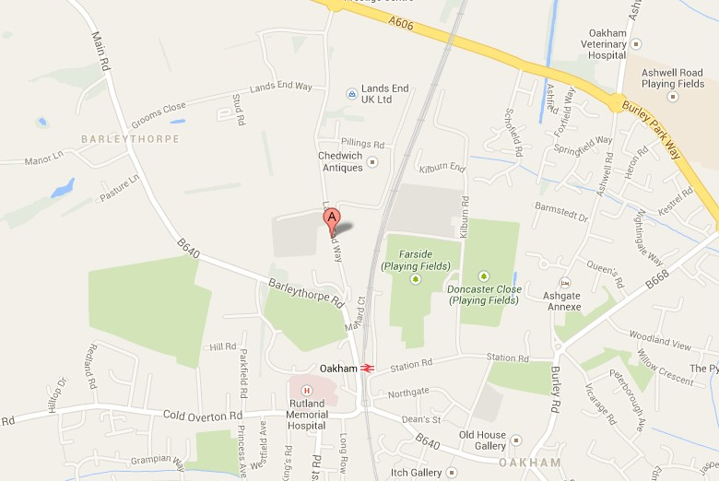
Free parking on site, including spaces for people with disabilities.

