

Healthwatch Rutland meeting in public

Date: Friday 15th May 2015 1.30-4.00pm
Venue: Gover Room, Voluntary Action Rutland
Lands End Way, Oakham, LE156RB

A G E N D A
Item | Lead | Report
1. Welcome, introductions & apologies | Chair
2. Declarations of interest | All
3. Minutes of the last meeting  To approve the minutes of the previous Board meeting held on Friday 20th March 2015 | Chair | Paper A
4. Progress log  Update on actions taken. | Chair | Paper B
5. Matters arising  Matters arising from the minutes not covered by the agenda | Chair
6. Dementia Task Group  - Margaret Demaine, Chair of the Dementia Task , will update the Board on the work of the group and a successful conference held on 22nd April 2015  - Questions & Answers |  | Paper C
7. Development and delivery of Healthwatch Rutland - Report from CEO  - Operational Group and Task Groups  - Enter & View  - Dementia Project  - Young People's Team  - Mental Health  - Learning Disability  - Carers  - Urgent Care 1 – Emergency Ambulances  - Urgent Care 2 – Minor Injuries & Urgent Care  - Partnership Working  - Communications  - Recruitment and Support of Volunteers  - Moving Forward into 2015/16 | CEO | Paper D
8. Policy and other matters requiring consideration by Healthwatch Rutland Board - reports from Chair  - Board Members . To note the temporary appointment of David Henson as Board Member until the AGM in September 2015.  - To receive a report from David Henson from UHL Board ( Paper E )  - Contract with Rutland County Council & Key Performance Indicators ( Paper F ) - to note  - Contract Requirement - Budget and Management Accounts April 2014 ( Paper G) - to note  - Contract Requirement - Public Engagement Plan 2015-16 ( Paper H )- for discussion and agreement  - Contract Requirement Making People's Views known ( Paper I)  - Contract Requirement - Supporting the involvement of People in Commissioning ( Paper I)  - Contract Requirement - Healthwatch Rutland Signposting Service ( Paper J )- For discussion and agreement  - Annual Report & Annual General Meeting 2015 ( Paper K)  - Quality Accounts 2015 ( Paper L ) - to note Healthwatch Rutland's submissions  - Better Care Together - Verbal update  - Collaboration with EMAS ( Paper M) - To note arrangements for Regionwide Collaboration  - Evaluation of Healthwatch by the Kings Fund ( Paper N) - For Information | Chair | Paper  E  F  G  H  I  J  K  L  M  N
9. Questions from members of the public | Public
10. Any other urgent Business
11. Dates of Future meetings
- Wednesday 17th June 2015 - 7.30-9.30pm - Audit Hall ,Empingham
- Friday 17th July 2015 - 1.30- 4pm -Gover Centre, Voluntary Action Rutland
- Wednesday 19th August 2015 - 6.30 - 8.30pm -Village Hall ,Lyddington
- Friday 18th September 2015 - 1.30-4pm - AGM Location to be agreed
- Thursday 15th October - 7.30-9.30 on Village Hall, Ryhall
- Friday 20th November 2015 - 1.30- 4pm on Gover Centre ,Voluntary Action Rutland

FOR THIS AGENDA IN ANOTHER FORMAT eg LARGE PRINT OR BRAILLE, PLEASE CONTACT HEALTHWATCH RUTLAND

By telephone- 01572 720381
@ By email -info@healthwatchrutland.co.uk

VOLUNTARY ACTION RUTLAND

How to get there:

By bus:

For the Oakham Hopper local bus timetable click here
Use Route Three and dismount behind the Rutland County College For bus services to/from other areas, click here

By train:

On foot: Leave the station by the exit to Platform 2, turn right along Barleythorpe Road to the first junction, bear right into Lands' End Way. The volunteer Centre is about 200 metres on the left-hand side. The entrance to the car park is just after the Volunteer Centre .

By car:


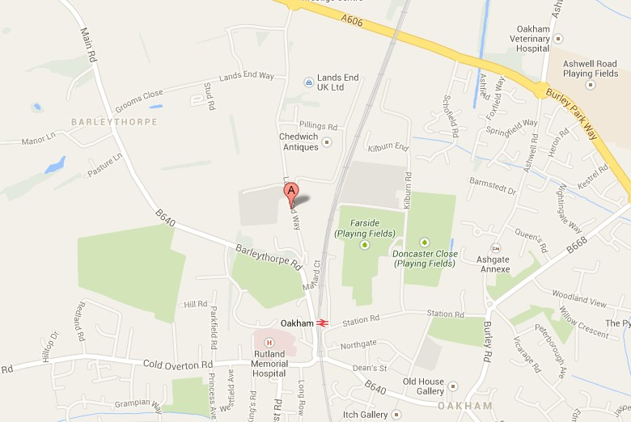
Free parking on site, including spaces for people with disabilities.

